EXP 6. Write a python program to implement List methods (Add, Append, Extend & Delete).
AIM:
To write and execute a Python program to implement list methods such as Add, Append, Extend, and Delete.
ALGORITHM:
- Start the program.
- Create a list with some elements.
- Add an element to the list using insertion.
- Append an element using the append() method.
- Add multiple elements using the extend() method.
- Delete an element using the del statement.
- Display the list after each operation.
- Stop the program.
PROGRAM:
L = [10, 20, 30]
print("Original List:", L)
L.insert(1, 15)
print("After Add:", L)
L.append(40)
print("After Append:", L)
L.extend([50, 60])
print("After Extend:", L)
del L[2]
print("After Delete:", L)

Output:
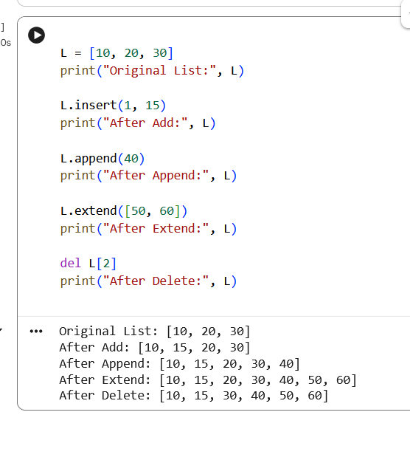
EXP 7. Write a python program to Illustrate Different Set Operations?
AIM:
To write and execute a Python program to illustrate different set operations such as union, intersection, difference, and symmetric difference.
ALGORITHM:
- Start the program.
- Create two sets, A and B.
- Perform union using union().
- Perform intersection using intersection().
- Perform difference using difference().
- Perform symmetric difference using symmetric_difference().
- Display the results of all operations.
- Stop the program.
PROGRAM:

A = {1, 2, 3, 4, 5}
B = {4, 5, 6, 7, 8}
print("Set A:", A)
print("Set B:", B)
print("Union:", A.union(B))
print("Intersection:", A.intersection(B))
print("Difference (A-B):", A.difference(B))
print("Difference (B-A):", B.difference(A))
print("Symmetric Difference:", A.symmetric_difference(B))
Output:
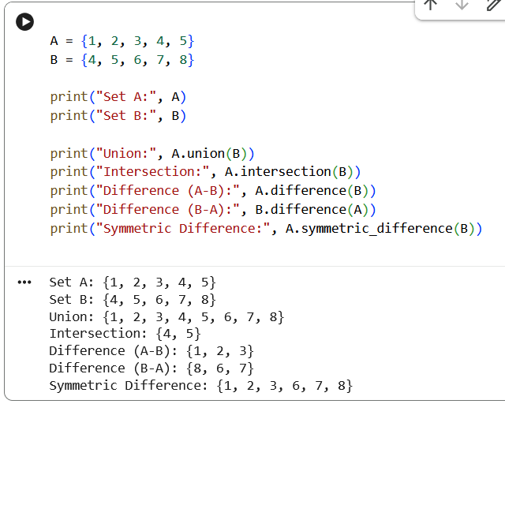
Exp 8. Write a python program to generate Calendar for the given month and year?
AIM:
To write and execute a Python program to generate a calendar for a given month and year.
ALGORITHM:
- Start the program.
- Import the calendar module.
- Get the month and year from the user.
- Generate the calendar using the month() function.
- Display the calendar.
- Stop the program.
PROGRAM:
import calendar
year = int(input("Enter year: "))
month = int(input("Enter month (1-12): "))
print(calendar.month(year, month))
Output:
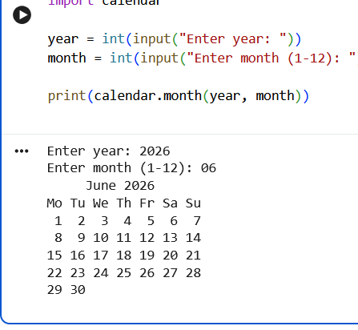
Exp 9. Write a python program to remove punctuations from the given string?
AIM:
To write and execute a Python program to remove punctuation marks from a given string.
ALGORITHM:
- Start the program.
- Import the string module.
- Get a string as input from the user.
- Initialize an empty string to store the result.
- Traverse each character in the given string.
- If the character is not a punctuation mark, add it to the result.
- Display the string without punctuation.
- Stop the program.
PROGRAM:
import string
text = input("Enter a string: ")
result = ""
for ch in text:
if ch not in string.punctuation:
result += ch
print("String without punctuation:", result)

Output:
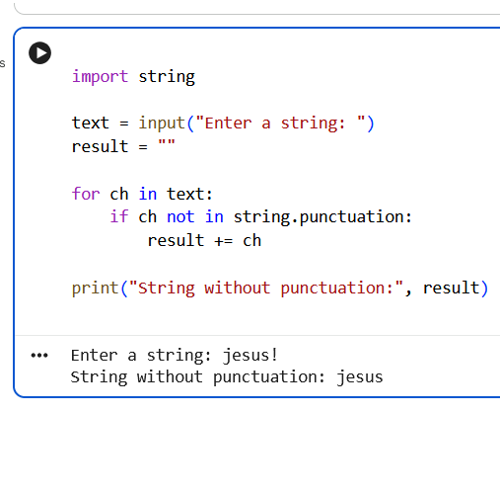
Exp 10. Write the python program to solve 8-Puzzle problem.
AIM:
To write and execute a Python program to solve the 8-Puzzle problem using the Breadth-First Search (BFS) algorithm.
ALGORITHM:
- Start the program.
- Define the initial state and goal state of the 8-puzzle.
- Insert the initial state into a queue.
- Remove a state from the queue and check whether it matches the goal state.
- If it matches, display the solution path.
- Otherwise, move the blank space up, down, left, or right to generate new states.
- Add unvisited states to the queue.
- Repeat until the goal state is reached or the queue becomes empty.
- Stop the program.
PROGRAM:

from collections import deque

start = (1, 2, 3,
4, 0, 6,
7, 5, 8)

goal = (1, 2, 3,
4, 5, 6,
7, 8, 0)

moves = [(-1, 0), (1, 0), (0, -1), (0, 1)]

queue = deque([(start, [])])
visited = {start}

while queue:
state, path = queue.popleft()

if state == goal:
print("Solution found:")
for step in path + [state]:
for i in range(0, 9, 3):
print(step[i:i+3])
print()
break

zero = state.index(0)
r, c = divmod(zero, 3)

for dr, dc in moves:
nr, nc = r + dr, c + dc

if 0 <= nr < 3 and 0 <= nc < 3:
pos = nr * 3 + nc
new_state = list(state)
new_state[zero], new_state[pos] = new_state[pos], new_state[zero]
new_state = tuple(new_state)

if new_state not in visited:
visited.add(new_state)
queue.append((new_state, path + [state]))
else:
print("No solution found.")

Output:
